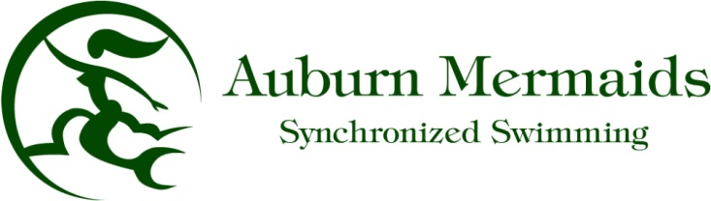

Greetings!

It is with great pleasure that we offer your organization the opportunity of becoming a valued sponsor
of the Auburn Mermaids Synchronized Swim Team. We are a recreational synchronized swim team for girls ages 5 to 18 years old in Auburn, California with nearly 70 swimmers on the roster for the 2017 season. The Mermaids have a tradition of more than 45 years here in Auburn. We swim in the Valley Foothill Competitive Athletic League along with five other Sacramento region teams. Synchronized swimming is a unique sport that incorporates extreme athleticism with flexibility, grace, and musicality.

Each year, our Mermaids learn routines that they perform in front of a judging panel in our weekly
meets and League Championships, as well as at our annual end of season community water show. The
routines are an exciting water performance and combine the team's talents with music and costumes to really put on an outstanding performance.

We are seeking sponsors for each of the 18 routines in our 2017 season in order to be able to purchase new team costumes and pay for the extra pool and coach time necessary for our routines to be competitive in championships. Our primary reason for these sponsorships is to keep costs to the girls low enough to make the sport accessible to more of Auburn’s youth.

Sponsorship levels are listed on the attached sponsorship form. As a sponsor, you or your organization will be recognized on our website and at our community water show in both the program and announced over the microphone during our water show. We will also proudly display your organization's advertising banner (if provided) at our home meets and water show.

We invite you or your organization to support this worthy cause with your charitable contribution and become a partner with the Auburn Mermaids! Due to the legal costs involved, we are not a 501 C3 non profit, but your sponsorship is a tax deductible advertisement for your business. For your convenience, we would be happy to pick up your donation. It can also be returned to the Auburn Recreation District office or sent to the address listed below.

If you need any additional information, please feel free to contact me at: theauburnmermaids@gmail.com or check out our team website at www.theauburnmermaids.com.

Respectfully,

Krista Greenlee
Head Coach, Auburn Mermaids Synchronized Swim Team
C/o Auburn Recreation District
123 Recreation Drive
Auburn, CA 95603
Auburn Mermaids Sponsorship Form

Sponsorship Levels:

Team level (8 swimmers) $400 < we need 4 at this level

Trio level (3 swimmers) $150 < we need 6 at this level

Duet level (2 swimmers) $100 < we need 6 at this level

Solo level (1 swimmer) $50 < we need 2 at this level

Mermaid level (any amount)

Please complete the following:

Organization:_____________________________________

Address:__________________________________________

Phone:____________________________________________

Contact person:_____________________________________

Sponsorship level:___________________________________

Amount enclosed:___________________________________

Please make checks payable to Auburn Mermaids.

Attach business card or display ad to this form for 2017 season advertising
purposes.
THANK YOU FOR YOUR SUPPORT OF OUR PROGRAM!!!

